WEDDINGS AT SAINT LEO THE GREAT CATHOLIC CHURCH
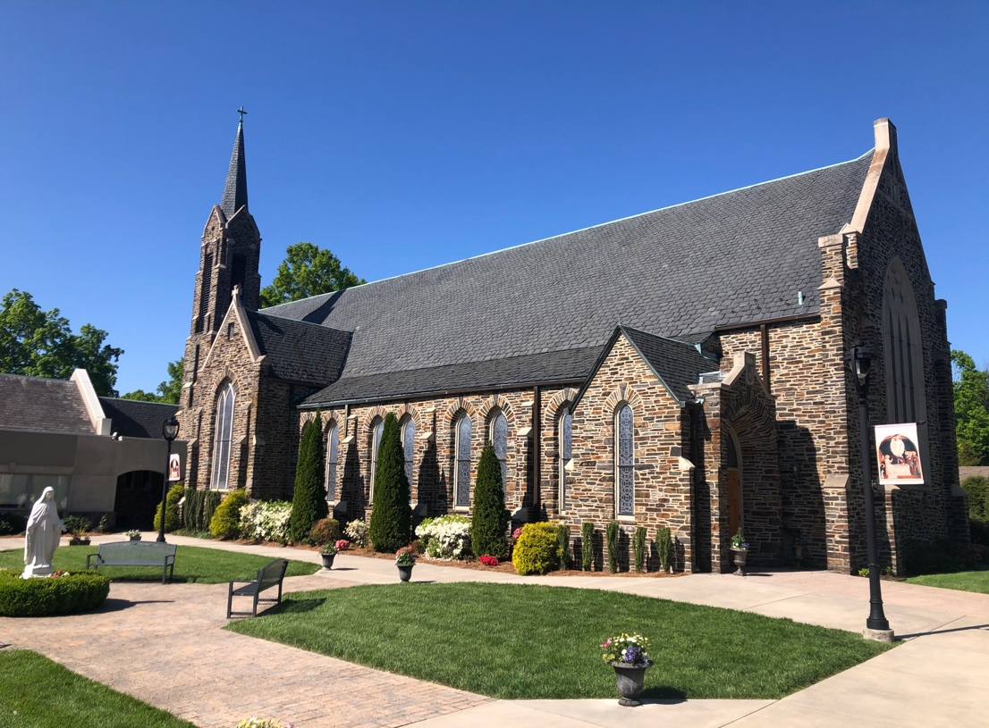

Our parish church is reserved for the celebration of the sacraments of registered and active Saint Leo parishioners and their families.
Who can be married at Saint Leo the Great?
All weddings conducted at Saint Leo must be those which are in conformity with the teachings of the Catholic Church.
For a couple to be married at Saint Leo, one of two conditions must be met:
- The bride or the groom is a registered, active, and regularly contributing member of Saint Leo and has been so for at least three months prior to the commencement of their six-month marriage preparation period. To be an active member means attending Mass every Sunday and supporting the parish financially.
- The bride or groom is a registered, active, and regularly contributing member of another parish, but attended Saint Leo as part of their childhood. The pastor of the bride or groom’s home parish must certify that the couple would be eligible for marriage in his parish.
All decisions about eligibility for marriage at Saint Leo are made by the pastor, and no date for a wedding can be reserved until he has done so.
When can weddings take place at Saint Leo?
Weddings are celebrated on open Saturdays at 11AM or 2 PM. Evening weddings are not permitted at Saint Leo.
Weddings are not scheduled on the following days:
- Saturdays of Advent and Lent
- Saturdays after Thanksgiving and Christmas
- Holy Days of Obligation that fall on Saturday
- All Souls Day when it falls on Saturday
- Saturday before the First Sunday of Advent
- July 4th weekend
- Saturday of the diocesan Eucharistic Congress in the fall (date varies).
Should the wedding be celebrated inside or outside of Mass?
- Under normal circumstances, all weddings at Saint Leo between a Catholic and a non-Catholic are celebrated outside of Mass.
- Weddings between two Catholics can be celebrated within the Mass, but only if both parties, and most of their immediate families, are genuinely and actively practicing the faith by attending Mass every Sunday. The final decision about this matter is made by the pastor.
How is the church reserved and a wedding date decided?
- To schedule your wedding at Saint Leo, please contact Mary Beth Young at mbyoung@stleocatholic.org. Before a date can be confirmed, your eligibility to be married at Saint Leo is first verified by the pastor, at least six full months from the date of the wedding.
What must be done before the wedding?
- A wedding is a simple ceremony lasting only a few minutes; a marriage is a lifetime commitment of sacrificial love in a solemn and sacramental covenant. Wedding preparation and marriage preparation are different things. Preparing for the marriage is by far more important. When you meet with one of the priests, they will explain the requirements for marriage preparation that must be completed before the celebration of the wedding.

How much does a wedding cost at Saint Leo?
- A $1000 fee offsets the costs associated with the use and cleaning of the parish facilities, and the stipends for all those involved in planning and assisting with the wedding, including the organist, cantor, and wedding coordinator. Checks payable to Saint Leo the Great Catholic Church are due 30 days prior to the wedding date.
- The wedding fee does not include an honorarium designated for the clergy who celebrates the Rite of Marriage, nor does it include any offering or gift which is made to the parish. The amounts of these stipends are left to the discretion of the bride and groom.
- The fee for any additional musicians hired by the couple, the cost of the printed wedding program, and the fee for the diocesan marriage preparation workshop are all borne by the bride and groom and handled independently by them.
- Couples for whom the church wedding fee would be a burden are welcome to speak with the pastor about a reduction of the fee.
The Bridal Gown and Bridesmaids’ Dresses
Please remember that your wedding is a sacred celebration taking place in a consecrated place of divine worship. Bearing in mind the reverence and decorum required by the sacred liturgy, we ask that your wardrobe selections reflect the modesty and noble simplicity which the Church expects. The shoulders of all women in the bridal party should be covered. Strapless attire is not appropriate for the bride, bridesmaids, mothers of both the bride and groom, and the flower girls.
Church Flowers
Wedding floral arrangements on either side of the tabernacle are normally quite sufficient. No flowers or greenery may be placed on or in front of the altar. It is customary for the wedding flowers to be left in the sanctuary for the weekend Masses.
Personal Flowers, Corsages and Boutonnieres
- The wedding party is responsible for making all arrangements for personal flowers, corsages, and boutonnieres to be worn or carried in the wedding. All flowers should be delivered to the church after 9AM on the day of the wedding.
- No flowers or greenery are permitted in the windows or aisles of the church, and no flowers or flower petals may be dropped inside or outside of the church before, during, or after the wedding or rehearsal. No decorations are permitted outside the church, including the railings.
- You may ask your florist to provide up to six floral pew markers, if they are of a small, simple design, and tied to the pew. The use of tape, nails, and tacks are not permitted. The wedding party is responsible for removing any pew markers immediately after the wedding.
- Aisle runners, rice, birdseed, bubbles, balloons, glitter, and sparklers are not permitted either inside or outside the church at any time.

Who plans the wedding liturgy?
- Weddings are public liturgical actions of the Church, and the celebration of weddings are governed by liturgical law. The basic form of the wedding liturgy is given by the Church, and no variation from that form is permitted. Within that basic form, the selection of the Scripture readings and prayers is made by the priest or deacon who will preside at the wedding, after consultation with the bride and groom. A list of possible readings is found at the end of this document.
- To assure conformity with the Church’s wedding liturgy, a final draft of the wedding program, if one is to be used, must be submitted to the church office for review and approval not less than three weeks prior to the wedding date. Please send to: mbyoung@stleocatholic.org
Candles and Liturgical Furnishings
- The furnishings for the sacred liturgy are provided by the church; this includes all vestments, books, candles and candlesticks, kneelers, chairs, and other elements as needed. We cannot use family heirlooms in the celebration of the sacred liturgy.
- In the sacred liturgy of the Church, candles are always a symbol of the Lord Jesus, but the “Unity Candle” (a recent innovation of American Protestant worship services) represents the bride and groom rather than Christ. The “Unity Candle” is not a part of the wedding liturgy of the Catholic Church, and it may not be used at Saint Leo for any reason. There are no exceptions to this policy.
Who plans the music?
- To plan the music for a wedding, you must meet with the Director of Sacred Liturgy. Because the celebration of a wedding is a public liturgical action of the Church, only music that is truly sacred is permitted at weddings. All decisions about the music allowed at Saint Leo are made under the supervision of the pastor, including permission to invite visiting vocalists and instrumentalists. Please speak with the Director of Sacred Liturgy before arranging for any other musicians, whether hired professionals, or volunteers from among family or friends. Steve Stringer: sstringer@stleocatholic.org
- Fees for visiting musicians are the responsibility of the bride and groom. Saint Leo does not act as an intermediary for payment of these fees. (The wedding coordinator should not be asked to give payment to musicians or vocalists during the rehearsal or the wedding.)
- No music or accompaniment by recording or automation is ever permitted before, during, or after the wedding or rehearsal.
Visiting Clergy
The priests and deacons of Saint Leo ordinarily preside at all weddings. Exceptions to this norm are rare and are usually made only because a member of the family or a very close friend is a priest or deacon from elsewhere. If you desire to invite a Catholic priest or deacon from outside the parish to preside at your wedding, you must first submit a written request to the pastor of Saint Leo that provides the name, title, address, and phone number of the cleric you want to invite. Only the pastor of Saint Leo can grant permission (canonical delegation) for a visiting cleric to preside at a wedding in this parish. The visiting cleric must also have his Chancery send the Chancery in Charlotte a letter of good standing to witness the marriage.
If you desire to invite a non-Catholic clergyman to participate in the wedding liturgy, you must first submit a written request to the pastor of Saint Leo that provides the name, title, and address of the clergyman you want to invite. Non-Catholic clergy are permitted to participate in a Catholic wedding by their presence in the sanctuary, but they cannot preside at the liturgy. This means, among other things, that the Catholic priest or deacon must receive the wedding vows and impart the nuptial blessing.
Programs
- Before you print your wedding program, the final draft must be reviewed and approved by the pastor no less than three weeks prior to the wedding.
- If Mass is being celebrated, please include in the printed program the Guidelines for the Reception of Holy Communion which is found at the end of this document.
- The program must also include an instruction to your guests not to take photographs or use electronic devices during the wedding. A sample instruction is found at the end of this document.
Lectors
At the wedding, the texts of Sacred Scripture must be proclaimed from the ambo, and the person who performs this function is called a lector. Most couples choose one or two persons from among their families and friends to perform this duty. Those whom you select should be good public speakers and must be at the rehearsal to practice the proclamation in the church; all lectors must be Catholics in full communion with the Church.
Guest Registry
Because of space limitations in the vestibules, guest registries are not permitted at Saint Leo. If the bride and groom desire a guest registry, please make arrangements at the reception venue.
Attendants in the Wedding
The bride and groom are permitted up to seven attendants each. The limit of seven each includes the bridesmaids and maid of honor, the best man and groomsmen, flower girls and ring bearers, and all honor attendants. Children under the age of six are not permitted to participate in the procession, or to stand in the front of the church, and this includes flower girls and ring bearers.
Food, Smoking, and Alcohol
No food or drink is permitted at any time inside the church and sanctuary before, during, or after the wedding and rehearsal.
Smoking is prohibited on the entire campus.
The wedding party is expected to refrain from using any alcoholic beverages before both the rehearsal and the wedding. The priest or deacon celebrating the wedding reserves the right to remove from the church anyone under the influence of alcohol. Please remind everyone in the wedding party to preserve the sacred character of this event by not abusing alcohol.
The Rehearsal
Rehearsals are scheduled for 5 PM the Friday prior to the wedding. The rehearsal will last one hour. The priest who will celebrate the wedding, or the wedding coordinator, oversees the rehearsal. The bride and groom must both be present and participate in the rehearsal; no proxies or stand-ins are allowed. All bridesmaids, groomsmen, flower girls, ring bearers, and lectors must be present at the rehearsal to practice the wedding liturgy.
The Marriage License
The bride and groom must bring the Marriage License to the rehearsal. The priest or deacon will complete this legal document in the sacristy with the bride and groom and their witnesses before the rehearsal begins. No wedding is permitted at Saint Leo without this document; please be sure to obtain the license at least one month before the wedding.
It is very important that the marriage license document be left inside the church office immediately following the wedding. Saint Leo is responsible for filing this document with the Clerk of Court.

Photographs
The requirements for photography at Saint Leo may be different from your experience of weddings at other churches. Please give careful attention to these policies and requirements during the planning session with your photographer.
Saint Leo reserves the right to exclude from working at our church any photographer who has not abided by these policies in the past. For this reason, please communicate with the church office before confirming a contract with your photographer.
- The photographer may arrive at the church one hour before the wedding. All photography, both interior and exterior, must be completed within 45 minutes of the conclusion of the wedding.
- Before the wedding, photographs of the groom, his groomsmen, and his family may be taken outside the church but not inside.
- Before the wedding, the bride, her family, and the bridesmaids may be photographed outdoors but not inside of the church.
- As the procession begins, the bride may be photographed walking down the aisle from the back of the church. The photographer should not position himself/herself in the aisle itself, in front or walking behind the advancing procession.
- Absolutely no flash photographs are permitted during the wedding liturgy.
- The photographer is not permitted to walk about in the sanctuary (altar area) during the wedding. Once the ceremony begins, he/she is not permitted to move closer than the second pillar from the front of the church.
- At the end of the wedding, the bride and groom may be photographed walking down the aisle and toward the main door of the church, but the photographer must remain in the rear of the church.
- After the wedding, the photographer may gather the entire wedding party inside the church for pictures. None of the sanctuary or altar furnishings may be moved for the purpose of this photographic session, and absolutely nothing may be placed on, or removed from, the sacred altar. All inside photographs must be completed within thirty minutes of the end of the wedding.
- If a videotape is to be made, all the above restrictions also apply.
- A separate photographer policy document, photographing a Wedding at Saint Leo the Great Catholic Church, which outlines the above policies, must be signed by your photographer, and returned to the church office not less than three weeks prior to the wedding. This document may be found at the end of this wedding policy.

What’s this all about?
Some of these policies may seem arbitrary or unreasonable on first reading, but we ask for your patience and understanding. Our policies are written to anticipate many of the most common difficulties that arise during the planning and celebration of weddings. We know that you want your wedding to be perfect and that you have probably been planning this day in your imagination for many years; we also know that some of the things you may have imagined might not coincide with the expectations set forth in these wedding policies. We ask you to remember, though, that while your wedding is an intensely personal moment for you, it is not a private event; rather, it is a public celebration of one of the seven Sacraments given to the Church by the Lord Jesus. For this reason, the pastor, deacon, and staff have a solemn duty to ensure that the sacred liturgy is celebrated according to the mind of the Catholic Church and in conformity with liturgical law.
Our policies are written to help you understand what is possible and what is not possible during the short ceremony that begins your lifetime of sacrificial love in the Sacrament of Holy Matrimony. The sacred liturgy of your wedding is above all else an act of divine worship and our policies are designed to make your wedding a beautiful and memorable encounter with Christ the Lord for you, your family, and your friends. If you have any questions about these policies, please feel free to speak with anyone listed in the “Contact Information” section which follows.
We, _____________________________(Groom) and __________________________(Bride) have received, read, understood, and agree to abide by the marriage policies of Saint Leo the Great Catholic Church. We understand that failure to follow these policies could result in a delay of our wedding even after the date has been set.
___________________________ __________ Signature of Groom Date
___________________________ __________ Signature of Bride Date
Please remember that the final draft of the wedding program (if any), the signed florist policy and the signed photographer policy, must be returned to the church office no later than three weeks prior to the wedding.

Contact Information
Mary Beth Young, Pastoral Assistant
scheduling and marriage preparation
336.724.0561
mbyoung@stleocatholic.org
Steve Stringer, Director of Sacred Music coordinating music and musicians for the wedding
336.724.0561
sstringer@stleocatholic.org
Rose Devanny, Parish Wedding Coordinator planning and organization of the wedding and rehearsal
rosedevanny17@yahoo.com

Amy Cuppett, Parish Wedding Coordinator
planning and organization of the wedding and rehearsal
amycuppett@hotmail.com

Church Office
336.724.0561
info@stleocatholic.org

Possible Scripture Readings for the Wedding Liturgy
The following readings are taken from the New American Bible, the only translation permitted for use in the sacred liturgy. The readings selected will be prepared by the church staff and placed on the ambo for the use of the lectors. It is not necessary for them to bring Bibles or photocopies of these readings to the wedding. Please review these readings and then discuss them with the priest or deacon who will preside at your wedding. The final choice of the readings is reserved to the cleric who will preside.
Old Testament Reading (first in order)
Genesis 1:26-28, 31a
Genesis 2:18-24
Genesis 24:48-51, 58-67
Tobit 7:6-14
Tobit 8:4b-8
Proverbs 31:10-13, 19-20, 30-31
Song of Songs 2:8-10, 14, 16a; 8:6-7a
Sirach 26:1-4, 13-16
Jeremiah 31:31-32a, 33-34
Psalm (second in order)
Psalm 33
Psalm 34
Psalm 103
Psalm 112
Psalm 128
Psalm 145
Psalm 148

New Testament Reading (third in order)
Romans 8:31b-35, 37-39
Romans 12:1-2, 9-18
Romans 15:1b-3a, 5-7, 13
1 Corinthians 6:13c-15a, 17-20
1 Corinthians 12:31-13:8a
Ephesians 5:2a, 25-32
Philippians 4:4-9
Colossians 3:12-17
Hebrews 13:1-4a, 5-6b
1 Peter 3:1-9
1 John 3:18-24
1 John 4:7-12
Revelation 19:1, 5-9a
Gospel Reading (fourth in order)
Matthew 5:1-12a Matthew 5:13-16 Matthew 7:21, 24-29 Matthew 19:3-6 Matthew 22:35-40
Mark 10:6-9
John 2:1-11 John 15:9-12 John 17:20-26

Guidelines for the Reception of Holy Communion
For Catholics, reception of Holy Communion is a most sacred act as we believe that the Eucharist is the Body, Blood, Soul and Divinity of Jesus Christ Himself. Therefore, before receiving Holy Communion, Catholics should be in full doctrinal communion with the Church and should have made a good sacramental confession if they have been conscious of any mortal sin. Out of respect for others’ faith traditions, the Catholic Church does not have intercommunion and so does not extend an invitation to Holy Communion for those who are not Catholic. The Catholic Church does, however, extend an invitation for those who would like to receive a blessing and to join us in a prayer of spiritual communion. If you would like to receive a blessing, please approach the priest at the time of Holy Communion with your arms folded across your chest as a sign of your intention.
Instruction regarding photographs and the use of electronic devices
Out of respect to the sacredness of the Marriage Rite, it is asked that all cell phones and other electronic devices be silent, and no pictures be taken during the ceremony. Thank you.

